CREATING A NEW DYESET

1. From the main overview screen click on the button



1. In the explorer type screen for dyeset on the right hand side Double click to open a new ‘colorant set’

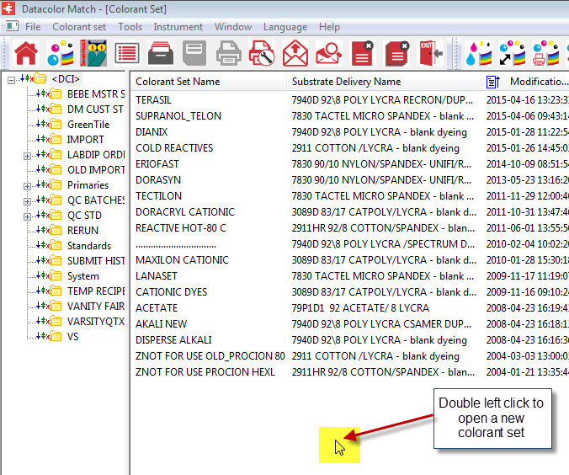

1. This will bring up the dyeset dialog box shown on the next screen.

Dyeset Dialog Box

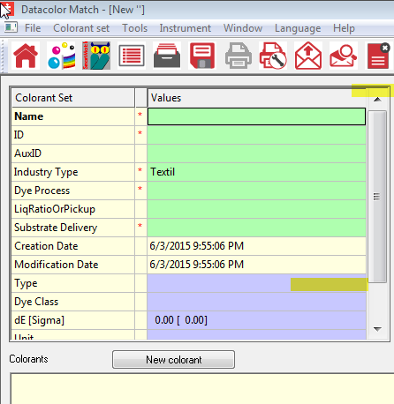

1. All fields with a red * must be filled in.
2. Click in the dyeset box next to the red asterick(*) and type in the dyeset name.
3. Click in the ‘ID’ box and an ID for the dyeset will be created.
4. Click on the dyeprocess box to the right of the asterick(*) then click on the browse button  and find the proper dyeprocess and click ‘ok’
5. You will add information in all required areas marked with the (*) as documented above.

# Adding Dyes to a Colorant Set.